Note the content shown here is generated by ChatGPT.

Machine Learning using Orange Tool – Complete Beginner Notes

These notes are designed for students who are completely new to Machine Learning and the Orange Data Mining tool.
Each concept is explained step-by-step with examples, following the exact workflow used in Orange.

--------------------------------------------------
1. Introduction to Machine Learning
--------------------------------------------------
Machine Learning (ML) is a field of Artificial Intelligence where computers learn patterns from data and make predictions or decisions without being explicitly programmed.

Types of ML:
• Supervised Learning – data has labels (e.g., diabetes prediction)
• Unsupervised Learning – no labels (e.g., clustering)
• Reinforcement Learning – learning via rewards (not covered in Orange basics)

--------------------------------------------------
2. Orange Data Mining Tool
--------------------------------------------------
Orange is a visual programming tool for machine learning where models are built using widgets instead of coding.

Advantages:
• No programming required
• Ideal for beginners
• Fast experimentation
• Visual understanding of ML pipeline

--------------------------------------------------
3. File Widget (Data Upload)
--------------------------------------------------
Purpose: Load dataset into Orange.

Supported formats:
• CSV, XLSX, TSV, TXT
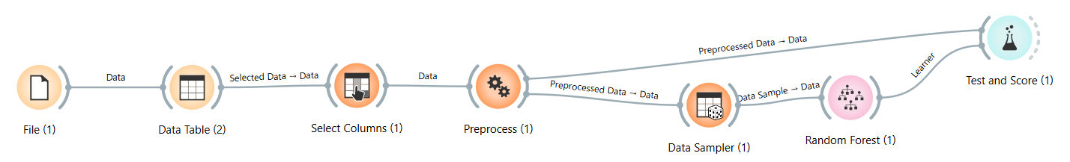
Example:
A diabetes dataset with columns:
Age, BMI, Glucose, Outcome

ML Step: Data Collection

--------------------------------------------------
4. Data Table Widget
--------------------------------------------------
Purpose: View and inspect data.

Key Uses:
• Check missing values
• Verify data types
• Understand dataset structure

Important:
This widget does NOT modify data.

ML Step: Exploratory Data Analysis (EDA)

--------------------------------------------------
5. Select Columns Widget
--------------------------------------------------

Purpose: Define roles of columns.

Roles:
• Feature (X): Input variables
• Target (Y): Output variable
• Meta: ID or descriptive fields

Example:
Features: Age, BMI, Glucose
Target: Outcome (Diabetes Yes/No)

Without target selection, model training will fail.

--------------------------------------------------
6. Preprocess Widget
--------------------------------------------------

Purpose: Clean and prepare data for ML.

Operations:
1. Imputation – handle missing values
2. Normalization – scale features
3. Discretization – convert numeric to categorical
4. Outlier removal

Example:
Missing BMI → replaced with average BMI

ML Step: Data Preprocessing

--------------------------------------------------
7. Data Sampler Widget
--------------------------------------------------

Purpose: Split data for training and testing.

Sampling Types:
1) Fixed proportion (e.g., 70% train, 30% test)
2) Random sampling
Data is split randomly multiple times, and results are averaged.
Example Setting
- Train size: 66%
- Repeat: 10 times
Example
10 different train–test splits:
- Split 1 → Accuracy = 84%
- Split 2 → Accuracy = 86%
- …
- Average accuracy = 85%
Advantages
- More stable than single split
- Less bias
Disadvantages
- Still not as reliable as cross-validation

3) Cross validation
Data is divided into K equal parts (folds).
Each fold is used once as test data.
Example Setting
- K = 5 (5-fold CV)
Example (5-fold)
Dataset = 500 rows
- Each fold = 100 rows
Runs:
- Train on folds 2–5, test on fold 1
- Train on folds 1,3–5, test on fold 2
…
- Train on folds 1–4, test on fold 5
Final accuracy = average of all 5 runs
Advantages
- Very reliable
- Every record is tested
- Best for small datasets
Disadvantages
- Slower
- More computation

4) Bootstrap
Random samples are drawn with replacement until the dataset size is reached.
Example
Dataset = 100 rows
Bootstrap sample:
- Still 100 rows
- Some rows repeated
- Some rows missing

Options:
• Replicable sampling – same result every run
• Stratified sampling – preserves class ratio

Example:
700 training records, 300 testing records

ML Step: Sampling & Validation

--------------------------------------------------
8. Machine Learning Algorithms
--------------------------------------------------
Common Learners:
• Logistic Regression – binary classification
• Decision Tree – rule-based model
• Naive Bayes – probability-based
• KNN – distance-based
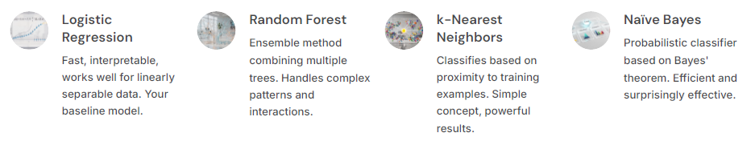
Read in Detail and write about each Algorithm:
Example (Decision Tree):
IF Glucose > 140 AND BMI > 25 → Diabetes = Yes

ML Step: Model Training

--------------------------------------------------
9. Test and Score Widget
--------------------------------------------------
Purpose: Evaluate model performance.

Problem context (assume):
- Positive = Disease present
- Negative = Disease absent

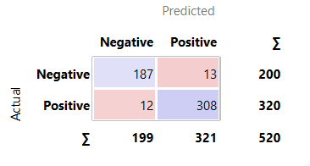

Common Metrics:
1) Accuracy
True Negative (TN) = 187
- Actual: Negative
- Predicted: Negative
✔ Correctly predicted non-disease cases
📌 Meaning:
187 healthy people were correctly identified as healthy.

2️⃣ False Positive (FP) = 13
- Actual: Negative
- Predicted: Positive
❌ Incorrectly predicted disease
📌 Meaning:
13 healthy people were wrongly told they have the disease.
⚠ Also called Type-I Error

3️⃣ False Negative (FN) = 12
- Actual: Positive
- Predicted: Negative
❌ Missed disease cases
📌 Meaning:
12 diseased patients were wrongly told they are healthy.
⚠ Also called Type-II Error
🚨 Very dangerous in healthcare

4️⃣ True Positive (TP) = 308
- Actual: Positive
- Predicted: Positive
✔ Correctly predicted disease cases
📌Meaning:
308 patients with disease were correctly detected.

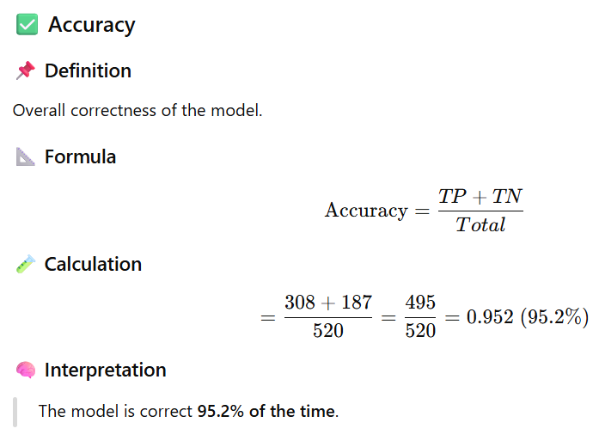

2) Precision
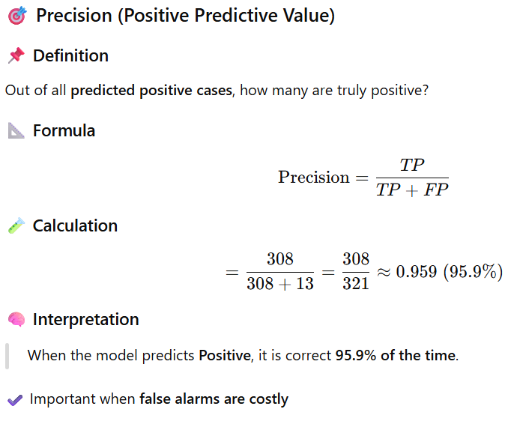

3) Recall
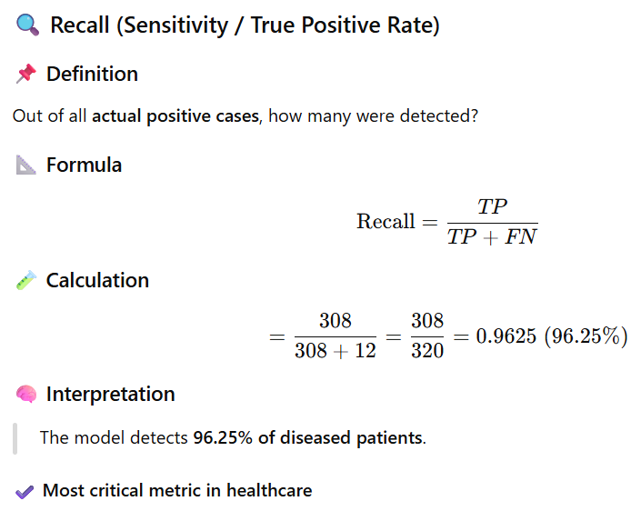

4) F1 Score
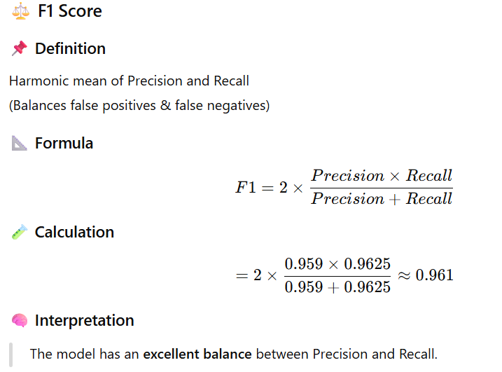

5) AUC
Learn it by urself and fill the space.

ML Step: Model Evaluation

--------------------------------------------------
10. Confusion Matrix Widget
--------------------------------------------------
Purpose: Detailed analysis of predictions.

Matrix:
True Positive (TP)
True Negative (TN)
False Positive (FP)
False Negative (FN)

Healthcare Insight:
False Negatives are dangerous as disease cases are missed.

--------------------------------------------------
11. Complete Orange ML Workflow
--------------------------------------------------
File → Data Table → Select Columns → Preprocess → Data Sampler → Learner → Test & Score → Confusion Matrix

Other Information:
